Buy Energy Back Into The Market

Priority: High

Customer Impact: High

Entering in a negative number into the units field on the Buy Energy page will result in units of energy being returned to the available pool. However this is outside of a sell transaction, the customer isn’t logged in and this impacts other customers on the site.

Steps to reproduce:

1. Navigate to the [Home](https://ensekautomationcandidatetest.azurewebsites.net/) page
2. Click Buy Energy button
3. Enter a negative number into one of the fields
4. Click the corresponding Buy button
5. On the Sale Confirmed screen, click the Buy More button

You will be returned to the Buy Energy screen, but there will now be more units of energy available than there was before. Units of energy have not been sold to us. This is an incorrect transaction.

We should not allow customers to return energy to use by specifying a negative number in the units field.

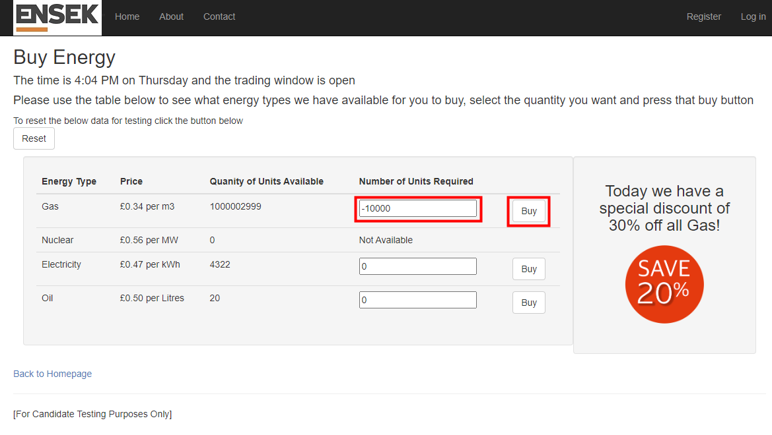

# 

# **Error**

## An error occurred while processing your request

### Input string was not in a correct format.

#### at System.Number.StringToNumber(String str, NumberStyles options, NumberBuffer& number, NumberFormatInfo info, Boolean parseDecimal) at System.Number.ParseInt32(String s, NumberStyles style, NumberFormatInfo info) at EnsekAutomationTest.UI.MVC.Controllers.EnergyController.Buy(FormCollection form) in C:\GIT\configurationTest\Test Application\EnsekAutomationTest.UI.MVC\Controllers\EnergyController.cs:line 81 at lambda_method(Closure , ControllerBase , Object[] ) at System.Web.Mvc.ActionMethodDispatcher.Execute(ControllerBase controller, Object[] parameters) at System.Web.Mvc.ReflectedActionDescriptor.Execute(ControllerContext controllerContext, IDictionary`2 parameters) at System.Web.Mvc.ControllerActionInvoker.InvokeActionMethod(ControllerContext controllerContext, ActionDescriptor actionDescriptor, IDictionary`2 parameters) at System.Web.Mvc.Async.AsyncControllerActionInvoker.<>c.<BeginInvokeSynchronousActionMethod>b__9_0(IAsyncResult asyncResult, ActionInvocation innerInvokeState) at System.Web.Mvc.Async.AsyncResultWrapper.WrappedAsyncResult`2.CallEndDelegate(IAsyncResult asyncResult) at System.Web.Mvc.Async.AsyncResultWrapper.WrappedAsyncResultBase`1.End() at System.Web.Mvc.Async.AsyncControllerActionInvoker.EndInvokeActionMethod(IAsyncResult asyncResult) at System.Web.Mvc.Async.AsyncControllerActionInvoker.AsyncInvocationWithFilters.<>c__DisplayClass11_0.<InvokeActionMethodFilterAsynchronouslyRecursive>b__0() at System.Web.Mvc.Async.AsyncControllerActionInvoker.AsyncInvocationWithFilters.<>c__DisplayClass11_2.<InvokeActionMethodFilterAsynchronouslyRecursive>b__2() at System.Web.Mvc.Async.AsyncControllerActionInvoker.<>c__DisplayClass7_0.<BeginInvokeActionMethodWithFilters>b__1(IAsyncResult asyncResult) at System.Web.Mvc.Async.AsyncResultWrapper.WrappedAsyncResult`1.CallEndDelegate(IAsyncResult asyncResult) at System.Web.Mvc.Async.AsyncResultWrapper.WrappedAsyncResultBase`1.End() at System.Web.Mvc.Async.AsyncControllerActionInvoker.EndInvokeActionMethodWithFilters(IAsyncResult asyncResult) at System.Web.Mvc.Async.AsyncControllerActionInvoker.<>c__DisplayClass3_6.<BeginInvokeAction>b__4() at System.Web.Mvc.Async.AsyncControllerActionInvoker.<>c__DisplayClass3_1.<BeginInvokeAction>b__1(IAsyncResult asyncResult)